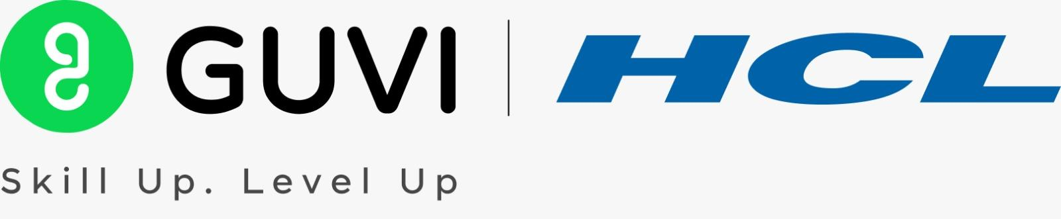
Project Excellence Series: Guided Learning & Problem Solving [EDA] [ENGLISH]

Recording link:

https://drive.google.com/drive/folders/1cieKq_nMAmw849qKofh6udC4hquWzCbi?usp=sharing

References:

https://drive.google.com/drive/folders/1_R559sXF7tnLMvQhnNlcxU3i5vNwS-9z?usp=sharing

Feedback form: https://forms.gle/Foy3qbMFof6xRs4u9

